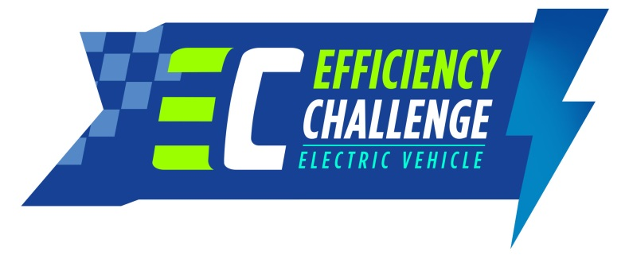

**TÜBİTAK EFFICIENCY CHALLENGE**

**ELECTRIC VEHICLE**

**pROGRESS Report**

***Deadline: April 14th, 2017***

**Vehıcle and Team Name: HARPUT 2 - FÜTEK**

**Unıversıty: FIRAT UNIVERSTY**

**Academıc Advısor: assoc. Prof. dr. orhan çakar**

**Team captaın: CUMAALİ YEŞİLKAYA**

|  |  |  |  |
| --- | --- | --- | --- |
| **Vehıcle Type:** | **√Electromobıle** | **□ Hydromobıle** |  |

CONTENTS

**Vehıcle and Team Name:** 1

**Unıversıty:** 1

**Academıc Advısor:** 1

**Team captaın:** 1

1.Team Information 4

2.Vehicle specifications table changes*)* 5

3.Domestic Components 6

4.Motor 7

a) Video links *(optional)* 7

*b)* Images *(must)* 7

5.Motor driver 8

a) Video links *(optional)* 8

*b)* Images *(must)* 8

6.Battery management system (BMS) 9

a) Video links *(optional)* 9

b) Images *(must)* 9

7.Embedded recharging unit 10

a) Video links *(optional)* 10

*b)* Images *(must)* 10

8.Energy Management System (EMS) 11

a) Video links *(optional)* 11

*b)* Images *(must)* 11

9.Fuel Cell (for Hydromobile category) 12

a) Video links *(optional)* 12

b) Images *(must)* 12

10.Mechanical details (chassis, roll bars, etc.) 13

a) Video links *(optional)* 13

b) Images *(must)* 13

# Team Information

1. *Enter only the name of the members who leftthe team, if any, after submissionof the application form.*

|  |  |  |  |
| --- | --- | --- | --- |
| **No** | **First name/Last name** | **Role** | **E-mail** |
| 1 |  |  |  |
| 2 |  |  |  |
| 3 |  |  |  |
| 4 |  |  |  |
| 5 |  |  |  |

1. *Enter only the name of the team members who wasnot submitted in the application form, if any.*

|  |  |  |  |
| --- | --- | --- | --- |
| **No** | **First name/Last name** | **Role** | **E-mail** |
| 1 |  |  |  |
| 2 |  |  |  |
| 3 |  |  |  |
| 4 |  |  |  |
| 5 |  |  |  |

# Vehicle specifications tablechanges*(highlight the changes in red)*

*Fill out thetable and specify the changes by highlighting the values if the values havechangedafter submission of the Application Form, in red colour.*

|  |  |  |
| --- | --- | --- |
| Feature | Unit | Value |
| Length | mm | 3000 |
| Width | mm | 1400 |
| Height | mm | 1200 |
| Number of wheels | # | 4 |
| Chassis | material | ALuminum 5803 HX3 |
| Shell | material | Fiberglass |
| The brake system | hydraulic disc, front, rear, hand brake |  |
| Diameter of front tyres | mm | 452 |
| Width of front tyres | mm | 80 |
| Diameter of rear tyres | mm | 492 |
| Width of rear tyres | mm | 130 |
| Telemetry | yes/no;  transmitted information (speed, battery status, temperature, etc.) | Yes;speed,battery status,temperature |
| Motor | type | BLDC |
| Motor driver | self-designed, ready-made product | Ready-made product |
| Motor power | kW | 4.5 |
| Motor efficiency | % | %95 |
| Engine weight | kg | 2*21 |
| Battery | type | LiFePO4 |
| Battery nominal voltage | V | 72 |
| Maximum voltage of the battery | V | 78 |
| Battery nominal voltage | Wh | 3000 |
| Fuel cell power* | kW | - |
| Number of hydrogen tubes* | # | - |
| Hydrogen tubepressure* | bar | - |
| Super capacitor* | yes/no | - |
| *\*Hydromobile category only* | | |

# Domestic Components

*In this section, teams are asked tocheck off the domestic sub-components they are planning to design themselves. The details of the domestic components will be given in Technical Design Report in July.*

|  |  |  |
| --- | --- | --- |
| 1. **Motor** | **Mandatory for Electromobile/Hydromobile** | **☐** |
| 1. **Motor driver** | **Mandatory for Electromobile/Hydromobile** | **☐** |
| 1. **Battery management system (BMS)** | **Mandatory for Electromobile/Hydromobile** | **☐** |
| 1. **Embedded recharging unit** | **Mandatory for Electromobile** | **☐** |
| 1. **Energy management system (EMS)\*** | **Mandatory for Hydromobile** | **☐** |
| 1. **Battery packaging** | **Optional** | **☐** |
| 1. **Telemetry** | **Optional** | **x☐** |
| 1. **Electronic differential application** | **Optional** | **x☐** |
| 1. **Vehicle control unit (VCU)** | **Optional** | **x☐** |
| 1. **Fuel cell\*** | **Optional** | **☐** |
| 1. **Fuel cell control system (circuit)\*** | **Optional** | **☐** |

*\* Hydromobile category only*

# Motor

*In this section, teams should present a maximum of two photographs showing the current form of the product which is going to be used in the competition. The sizes of the photographs should beat least800x600. If available, hyperlinks to the multimedia files related to the product can also be provided here.*

## Video links*(optional)*

## Images*(must)*

[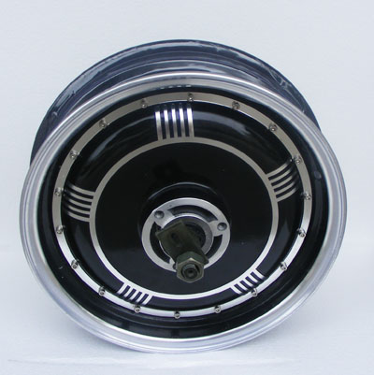](http://kellycontroller.com/images/48V_3KW_Motor.jpg)

# Motor Driver

*In this section, teams should present a maximum of two photographs showing the current form of the product which is going to be used in the competition. The sizes of the photographs should be at least800x600. If available, hyperlinks to the multimedia files related to the product can also be provided here.*

## Video links *(optional)*

## Images *(must)*

[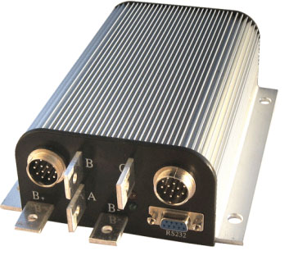](http://kellycontroller.com/images/brushless.jpg)

# Battery Management System (BMS)

*In this section, teams should present a maximum of two photographs showing the current form of the product which is going to be used in the competition. The sizes of the photographs should be at least800x600. If available, hyperlinks to the multimedia files related to the product can also be provided here.*

## Video links*(optional)*

<http://www.example1.com>

<http://www.example2.com>

## Images*(must)*

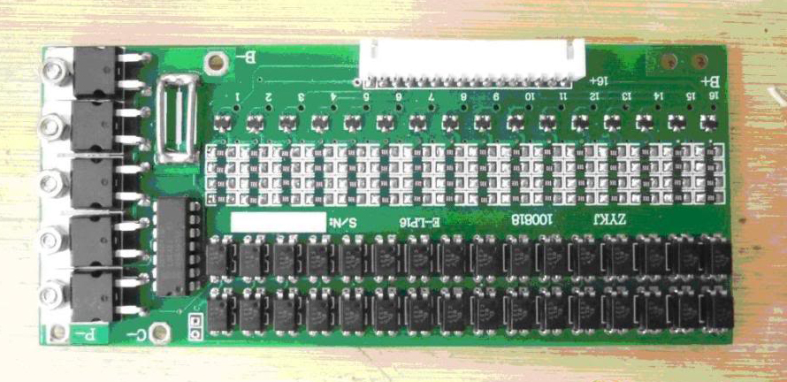

# Embedded Recharging Unit

*In this section, teams should present a maximum of two photographs showing the current form of the product which is going to be used in the competition. The sizes of the photographs should be at least800x600. If available, hyperlinks to the multimedia files related to the product can also be provided here.*

## Video links *(optional)*

<http://www.example1.com>

<http://www.example2.com>

## Images *(must)*

*Not inside*

# Energy Management System (EMS)(for Hydromobile category)

*In this section, teams should present a maximum of two photographs showing the current form of the product which is going to be used in the competition. The sizes of the photographs should be at least800x600. If available, hyperlinks to the multimedia files related to the product can also be provided here.*

## Video links *(optional)*

<http://www.example1.com>

<http://www.example2.com>

## Images *(must)*

*Insert the images in the blank space.*

# FuelCell(for Hydromobile category)

*In this section, teams should present a maximum of two photographs showing the current form of the product which is going to be used in the competition. The sizes of the photographs should be at least800x600. If available, hyperlinks to the multimedia files related to the product can also be provided here.*

## Video links*(optional)*

<http://www.example1.com>

<http://www.example2.com>

## Images*(must)*

*Insert the images in the blank space.*

# Mechanical details (chassis, roll bars, etc.)

*In this section, teams should present a maximum of two photographs showing the current form of the product which is going to be used in the competition. The sizes of the photographs should be at least 800x600. If available, hyperlinks to the multimedia files related to the product can also be provided here.*

## Video links *(optional)*

<http://www.example1.com>

<http://www.example2.com>

## Images *(must)*

